NAME:_________________________________ALGEBRA 2 COMMON CORE
TEST Review

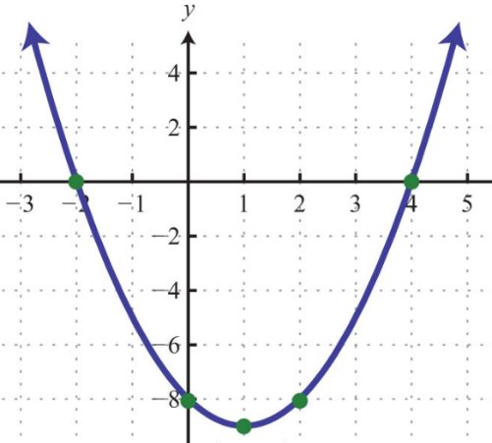
Find the average rate of change over the interval [0,4].

Let $h\left(x\right)=5x+2, p\left(x\right)=\frac{1}{3}x-3, and q\left(x\right)=-2x+4.$ Find $\left(h ∘p \right)\left(18\right).$

Find the vertex of the quadratic equation, $y=\frac{1}{11}{\left(x-9\right)}^{2}+27.$

Find a quadratic regression for the data below which represents the average rainfall per year for Rochester, NY. Let $x=0$represent$1985$. (round to the nearest thousandth)
Year | 1985 | 1990 | 1995 | 2000 | 2005 | 2010 | 2015 | 2018
Rainfall | 39” | 37.8” | 34.3” | 30.1” | 28” | 34.4” | 36” | 40.1”

What type of solutions does the quadratic equation $3x^{2}-9x+16=0$ have?

- real, irrational, unequal

- real, rational, unequal

- real, rational, equal

- imaginary

What is the simplified form of $\left(2+\sqrt{-81}\right)-(-4-\sqrt{-1} )$

Solve 3$x^{2}-9x-17=0$ for $x$, algebraically.

Write the equation of the circle in standard form, then identify the center of the circle and radius.

$${3x}^{2}+{3y}^{2}+6x-24y+30=0$$

Write an equation of a parabola with a focus of $\left(-1, 2\right)$ and a directrix of $y=4.$

- State the vertex.

- Write the equation of the parabola.

- Sketch the parabola.

Solve each of the following by factoring. Show all work.

- $4x^{2}-24x=0$ b. $2x^{2}-x-10=0$

Graph on axes below. Label the solution set S.

$y≤x^{2}-2x-8$

State the coordinates of ONE point in the solution set S: __________

Solve the system of three equations and three unknowns.

 | x | + | y | − | z | = | 4
 | x | − | 2y | + | 3z | = | −6
 | 2x | + | 3y | + | z | = | 7

